June 3, 2021

Dear Summit Academy Families:

As the number of COVID-19 cases in Ohio and nationwide continues to decrease, Summit Academy plans for all 24 schools to return to full-time, in-person classroom learning for the 2021-2022 school year.

We will monitor the status of COVID-19 and any related health and safety regulations during the summer months and keep you updated on any changes.

Thank you for your continuing efforts to keep our Summit Academy family and those around each of us safe.

Please enjoy a safe, fun, and relaxing summer. We look forward to seeing you in August!

Sincerely,
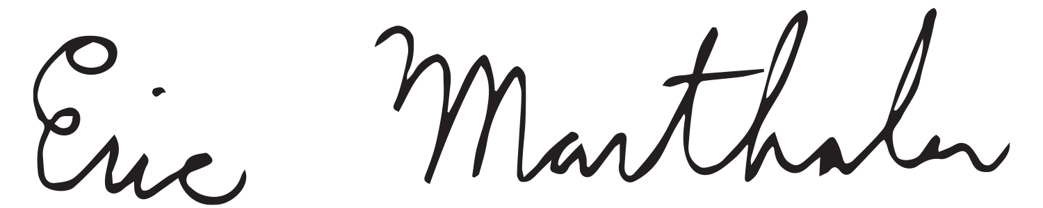
Eric Marthaler
Superintendent
Summit Academy Management

