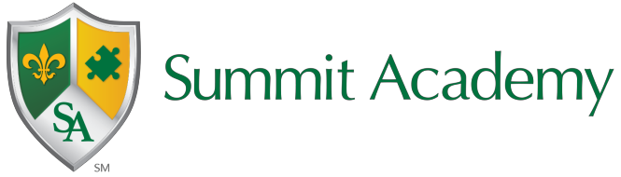
Summit Academy Middle School-Columbus
Student Wellness Plan 2023-2024

The Department of Education and Workforce has implemented the Future Forward initiative to focus on the whole child's needs. The state has provided student wellness funds for Ohio schools to ensure that the well-being of students specific to their physical, emotional, social, and academic needs are met.
Student Wellness and Success Funding Allocation
The student wellness and success funds are allocated to each Summit Academy school and are included in the monthly foundation payment. There are specific guidelines and expectations as to how the funds are spent. For the FY24 school year, the Department of Education and Workforce has updated the requirements for using Student Wellness and Success Funds.
These additions include:
- Spend at least 50% of Student Wellness and Success Funds on physical or mental health services.
- Develop a Student Wellness funding plan in collaboration with both a community mental health prevention or treatment provider and another community partner.
- Share the Student Wellness and Success Fund plan with the governing body and post it to the website within 30 days after the development or amendment of the plan.
- Report annually on how the district or school spent Student Wellness and Success Funds and Disadvantaged Pupil Impact Aid.
- Spend Student Wellness and Success Funds by the end of the next fiscal year.

Estimated Annual Student Wellness and Success Funds: $14,634.18

Needs Assessment and Goals
The Student Wellness and Success Funds plan began with completing the One Needs Assessment in the spring and reviewing our root cause analyses. Through this process, we have identified that we need to improve our academic outcomes specific to English Language Arts and Math and provide comprehensive behavioral support for students, including education for parents and staff. We have aligned the usage of these funds with the One Plan goals specific to academic improvement and decreased behavior incidents.

Community Partners
All Summit schools work in collaboration with mental health organizations to address the behavioral, physical, and emotional health of our students. Summit Academy Middle School- Columbus has partnered with The Village Network. This organization focuses on students’ mental health needs with an emphasis on student coping strategies and family support.
Summit Academy Community School-Columbus has also partnered with the Educational Service Center- Lake Erie West, focusing on increased academic progress and student engagement. This partnership ensures that best practices and appropriate instructional strategies are being implemented with fidelity.

Student Wellness and Success Funding Initiatives
After analyzing the needs assessment data and aligning it to the One Plan goals, we have determined one initiative for the Student Wellness Plan.
Initiative: Increasing Social-Emotional Learning Opportunities
Funding Plan: Support the salary cost of the Martial Arts Instructor

Summit Academy schools, founded in 1999, stemmed from an after-school martial arts program for children with ADHD, Autism, and other disabilities. During the after-school program, it was noticed that this program yielded an increase in social-emotional skills and academic performance for its participants. Summit Academy Schools embed a Therapeutic Martial Arts program into the academic school day. The mission of the Summit Academy Therapeutic Martial Arts program is to provide for the physical, mental, emotional, and social growth of our students using a specifically designed, multicultural martial arts program that targets different learning styles. By creating a program that teaches the fundamentals of martial arts specific to the age, development levels, and individual learning abilities of our students, the therapeutic, interdisciplinary, and interactive approach builds a foundation for our student growth objectives. In addition to teaching martial arts techniques, the Therapeutic Martial Arts programs supported by these funds work in conjunction with building leadership teams, classroom teachers, and families to provide social-emotional learning. Therapeutic Martial Arts supports all tenets of PBIS. Students of all grade levels K-12, who participate in Therapeutic Martial Arts classes, develop lifelong skills such as self-control, courtesy, humility, cooperation, patience, and perseverance.

