September 30, 2020

Dear Summit Academy Families:
Thank you, families and students, for the hard work and commitment to education you continue to display during the COVID-19 pandemic. These have been such unconventional and uncertain times and your support has been invaluable in seeing our students through them successfully. We have been planning for our second quarter, which runs from October 19 to December 18, with great care. After reviewing multiple scenarios, we have decided to extend remote learning through the second quarter of the school year.

This decision came after several discussions and considerations. Maximizing safety for our students, staff, and families and following local health department guidelines were among many factors taken into consideration. While we ultimately look forward to the full-time return of our students safely to our physical school building, we are happy to report many successes we have experienced during our remote period. Students are engaged, thriving, and turning in assignments as expected. Parents, guardians, and families have expressed ongoing empathy for each other’s circumstances. Our students are building relationships online. This is just a small sampling of the triumphs we have seen.

As always, we are committed to serving your children socially, emotionally, and academically. Likewise, we will continue to maintain structure in their school days. One-on-one meetings for students with IEPs, ETRs, and other diagnostics will remain as scheduled. Our principals, teachers, and other staff members will continue to serve your student at the highest level. As a school family, we remain committed to doing all we can to ensure the safety of our children, families, and staff.

We will be planning for our third quarter and will notify you of a plan by December 11.

If you have specific questions, please contact your school principal directly. Again, thank you for your support and commitment to your children’s education as we navigate through the challenges of this pandemic together.

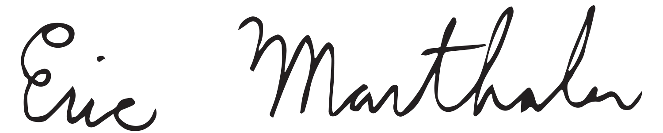
Respectfully,

Eric Marthaler, Superintendent

