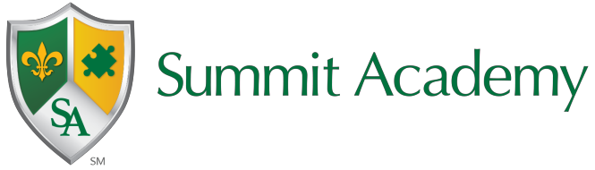
Summit Academy Secondary School-Akron
Student Wellness Plan 2023-2024

The Department of Education and Workforce has implemented the Future Forward initiative to focus on the needs of the whole child. The state has provided student wellness funds for Ohio schools to ensure that the well-being of students specific to their physical, emotional, social, and academic needs are met.
Student Wellness and Success Funding Allocation
The student wellness and success funds are allocated to each Summit Academy school and are included in the monthly foundation payment. There are specifc guidleines and expectations as to how the funds are spent. For the FY24 school year, the Department of Education and Workforce has updated the requirements for the usage of Student Wellness and Success Funds. These additions include
- Spend at least 50% of Student Wellness and Success Funds on physical or mental health services.
- Develop a Student Wellness funding plan in collaboration with both a community mental health prevention or treatment provider and another community partner.
- Share the Student Wellness and Success Fund plan with governing body and post to website within 30 days after development or amendment of the plan.
- Report annually on how the district or school spent Student Wellness and Success Funds and Disadvantaged Pupil Impact Aid.
- Spend Student Wellness and Success Funds by the end of the next fiscal year.

Estimated Annual Student Wellness and Success Funds: $ 22,815.58

Needs Assessment and Goals
The Student Wellness and Success Funds plan began with the One Needs Assessment completed in the spring, reviewing our root cause analyses. Through this process we have identified that we need to improve our academic outcomes specific to English Language Arts and Math, and provide comprehensive behavior supports for students, including education for parents and staff. We have aligned the usage of these funds with the One Plan goals specific to academic improvement and decreased behavior incidents.

Community Partners
All Summit schools work in collaboration mental health orginizations to address the behavioral, physical, and emotional health of our students. Summit Academy Secondary School- Akron has parterned with The Village Network. This organziation focuses on students’ mental health needs with an emphasis on student coping strategies and family support.
Summit Academy Secondary School-Akron has also partnered with The Educational Service Center of Lake Erie West, focusing on increased academic progress and student engagement. The parternship ensures that best practices and appropriate instructional sttrategies are being implemented with fidelity.

Student Wellness and Success Fundsing Initiaves
After analyzing the needs assessment data and aligning to the One Plan goals, we have determined three initatives for the Student Wellness Plan.

Initative: Physical activity improving mental health
Funding Plan: Support the salary of a physical eduation teacher

Physical education programming focuses on the benefits of a healthy, active lifestyle. Our goal is to improve students’ physical and mental health. Through the health and physical education courses, opportunities for discussions aligned to physical and mental health are imperative. Hands-on learning, including practicing physical exercises and activities that can be in corporated into an active, healthy lifestyle are provided. Students will also learn about the consequences of unhealthy lifestyle choices and the impact on the body and mind. Offering engaging academic activities will motivate students to be present at school, and helps students stay focused on regulating their own behavi ors to ensure participation. These successful experiences will raise their confidence and engagement in regular schoolwork while positively impacting their personal life. Problem-solving and real life examples related to the importance of a healthy mind and body will allow students to develop mental habits and executive functioning skills that will help them succeed in many areas of life, in and out of school.

