_____________________________________________________________________________________
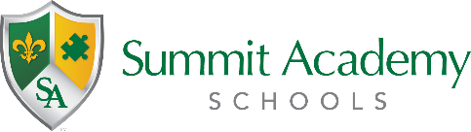
Governing Authority Meeting
Public Notice

Date: Tuesday, May 3, 2022
Time: 4:00pm
Location: 5800 Salvia Ave., Cincinnati, OH 45224-3029

The Governing Authority of Summit Academy Community School – Cincinnati has scheduled a regular meeting to be held at the above date, time, and location.

The meeting is open to the public.

