_____________________________________________________________________________________
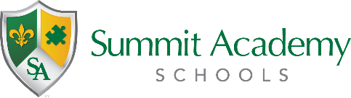
Governing Authority Meeting
Public Notice

Date: Wednesday April 6, 2022
Time: 5:30PM
Location: Virtual

The Governing Authority of Summit Academy Community School – Warren has scheduled a regular governing authority meeting to be held at the above listed date and time. The meeting is open to the public and will be held virtually. It may be accessed via the information below:

Microsoft Teams meeting
Join on your computer or mobile app
Click here to join the meeting
Or call in (audio only)
+1 234-901-0306,,569449106# United States, Akron
Phone Conference ID: 569 449 106#
Find a local number | Reset PIN
Learn More | Meeting options

