_____________________________________________________________________________________________

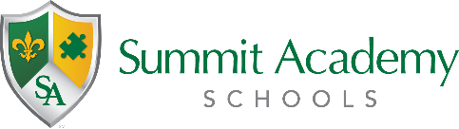
Governing Authority Meeting
Public Notice

Date: Monday, March 28, 2022
Time: 6:00PM
Location: Virtual

The Governing Authorities of Summit Academy Akron Elementary School, Summit Academy Akron Middle School, and Summit Academy Secondary School – Akron have re-scheduled the joint regular governing authority meeting from March 21, 2022 to the above listed date and time. The joint meeting is open to the public and can be accessed via the information below.

Microsoft Teams meeting
Join on your computer or mobile app
Click here to join the meeting
Or call in (audio only)
+1 234-901-0306,,506443504# United States, Akron
Phone Conference ID: 506 443 504#
Find a local number | Reset PIN
Learn More | Meeting options

