_____________________________________________________________________________________
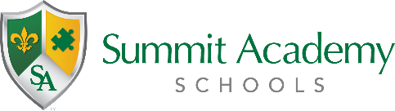
Governing Authority Meeting
Public Notice

Date: March 1, 2022
Time: 4:00pm
Location: 5800 Salvia Ave., Cincinnati, OH 45224-3029

The Governing Authority of Summit Academy Community School – Cincinnati will hold a regular meeting at the date, time, and the location above. Please note the meeting has been updated from the regular rotation at 1660 Sternblock Lane.

The meeting is open to the public.

