_____________________________________________________________________________________
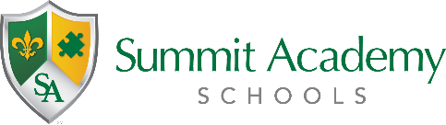
Joint Governing Authority Meeting
Public Notice

Date: Wednesday, January 26, 2022
Time: 5:30PM
Location: 2521 Fairwood

The Governing Authorities of Summit Academy Community School – Columbus, Summit Academy Middle School - Columbus, and Summit Academy Transition High School – Columbus have re-scheduled the joint regular governing authority meeting originally scheduled for Wednesday, January 12, 2022 to the above listed date, time, and location.

The meeting is open to the public.

