FAMILY COOKING AND COMMUNITY RESOURCES

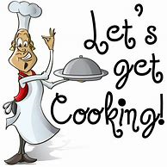

DATE: DECEMBER 14TH THROUGH DECEMBER 18TH
WHERE: JOIN US IN YOUR STUDENTS SOCIAL SKILLS CLASS
DETAILS: STUDENTS WILL LEARN TO COOK TWO DISHES AND
WILL BE GIVEN THE FOOD TO MAKE THE MEAL AS A
FAMILY.

FOOD PICK UP: DECEMBER 16 - 8 to 5
DECEMBER 17 – 8 to 5
DECEMBER 18 – 8 to 3

INFORMATION FOR COMMUNITY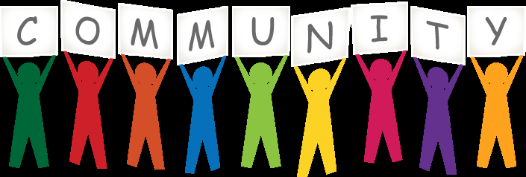 SERVICES WILL ALSO BE AVAILABLE

