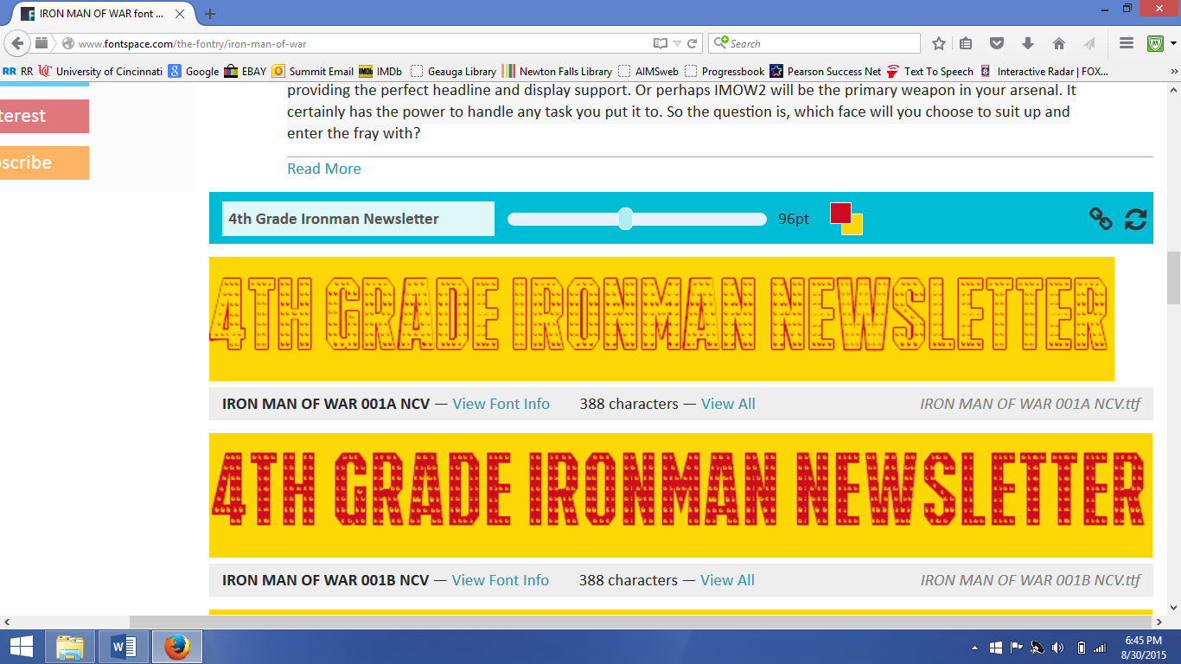

## Jan. 29, 2018

### *Miss Lewis and Mrs. DeSantis*

### 4th- Language Arts:

**This week we will begin a new story entitled *Dear Mr. Winston*. We will be focusing on understanding characters, as well as, drawing conclusions. Please look for new vocabulary words.**

***Mrs. Coy & Miss Bodnar***

**Report cards should have been received. We have started the second semester and that means that we have finished half of the school year.**

**Upcoming: Craft Day is Saturday, Feb. 3, so please return your paper to let us know if your child will or will not be joining us.**

**Parent Teacher Conferences Feb. 15-16th**

***(You will receive a call if your child’s teacher needs a conference)***

**No School: February 19th: President’s Day**

**Black History Month begins Feb.1 and we will learn about famous African Americans daily.**

**Read Across America: February 26-March 2. We’re planning to include some special readers!!!!**

**January is all about *Courage* and**

**February is all about Invincible Grit.**



***Mrs. Coy & Miss Bodnar***

**Social Studies: Life after the Ice Age**

**Math: Everyday your child will be tested over multiplication or division facts. In addition to a daily quiz, we will begin studying how to use multiples and factors in Topic 7 and apply this knowledge to fractions in Topic 8. This is another good reason why your child needs to learn their multiplication facts.**

and Ethen

**SHOUT OUTS:**

**January’s Reading and free Pizza Hut: Congratulations go to Daniel, Makayla, Charles, Bethany, Mason, Lucas, Sean, and Ethen**

**Happy Birthday to Miss Bodnar on January 31st!!!!**

**Ethen and Makayla have been chosen to be the Ironman’s leaders for the Glorious Kindness League and we couldn’t be prouder. Your children will be rallied to become involved and spread a little kindness with them.**